

**Wireless Communications**

Homework 2

Name: Oliger Verónica Mendoza Betancourt 奥莉歌

Student ID: D202161028

School of Computer and Communication Engineering

Information and Communication Engineering

Lecturer: Du Bing.

University of Science and Technology Beijing

30 Xueyuan Road，Haidian District

Beijing 100083，P.R.CHINA

Date of Submission: 2022/05/02

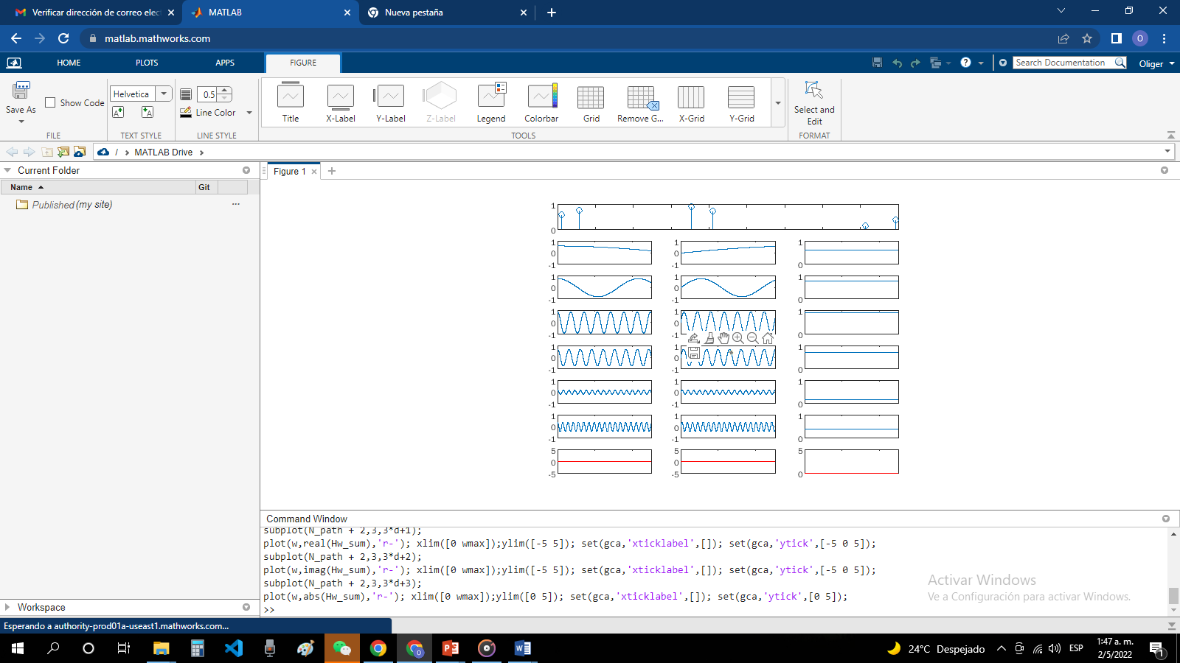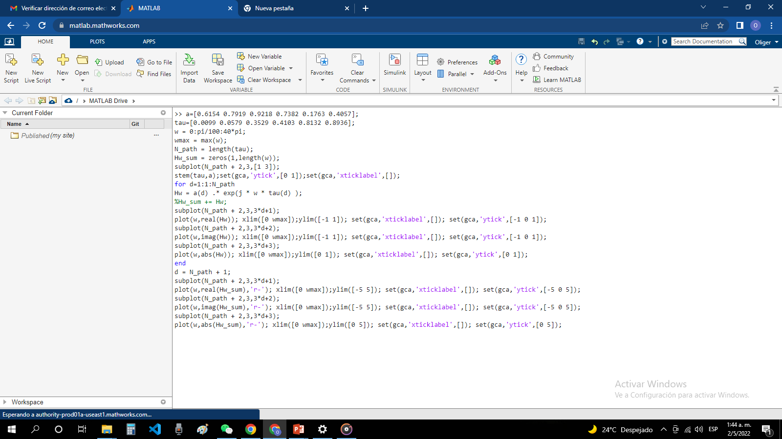

For this graphics, the signal from a transmitter radiates in one direction, this radiated signal takes a different path and arrives at the receiver at a different time and with a different signal strength (amplitude), the plot shows a signal attenuated by a constructive signal combination. motivated by the phase shift of the signal.

The signal becomes drastically different from the original signal transmitted from the source. The quality of the combined signal at the receiver became poorer (deteriorated) than the original signal. This type of signal deterioration process due to the multiple propagation path of a signal is called 'Fading', implying that the quality of the signal worsened.

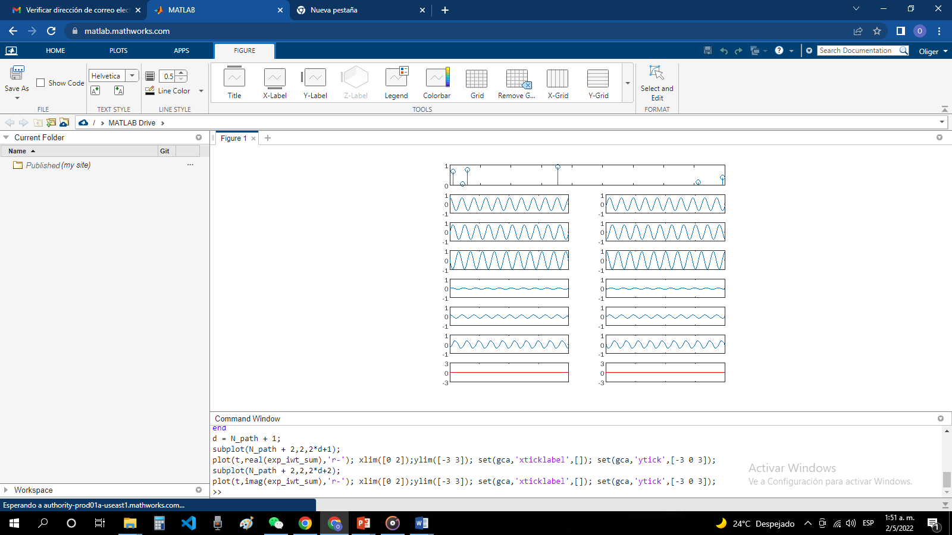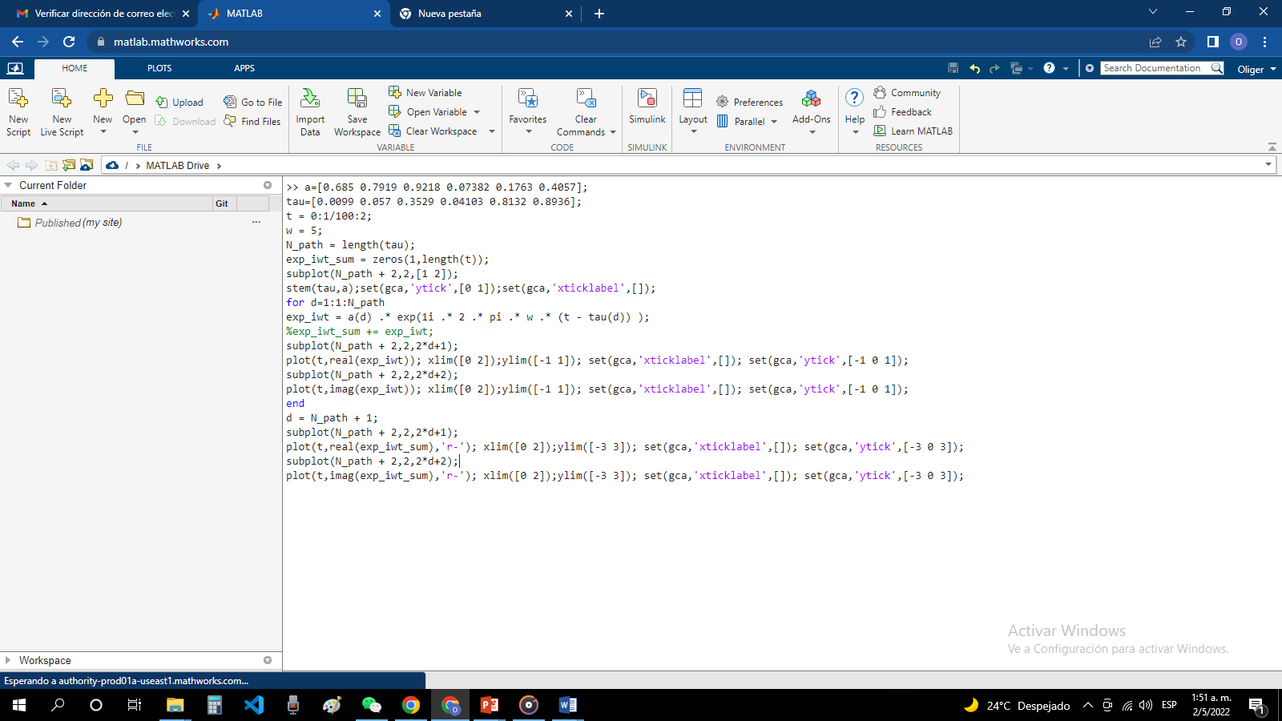

It is observed in each graph that the phase (time delay) and the amplitude are different from each other.

And the last diagram shows the sum of all the diagrams from (2) to (6). This is the signal that the receiving antenna detects, a transmitted signal that has changed shape and means that distortion has occurred over this multipath.

Large-Scale Fading – This can also be referred to as “slow fading” and is primarily due to loss of signal along the path as a function of distance and shadowing by large objects such as buildings and hills. This occurs when the mobile moves through a distance of the order of the cell size, and is normally independent of frequency.